People Need People - Benjamin Zephaniah
To walk to
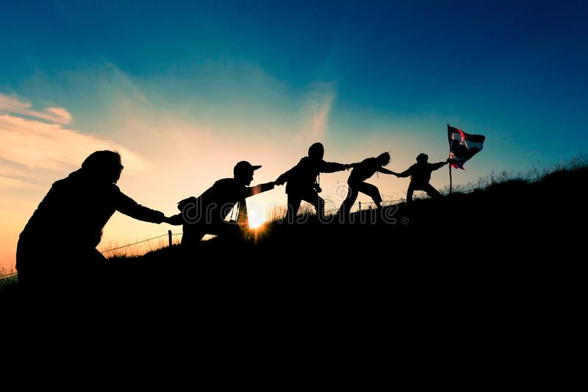
To talk to
To cry and rely on,
People will always need people.
To love and to miss
To hug and to kiss,
It’s useful to have other people.
To whom to moan
If you’re all alone,
It’s so hard to share
When no one is there.
There’s not much to do
When there’s no one but you.
People will always need people.
To please
To tease
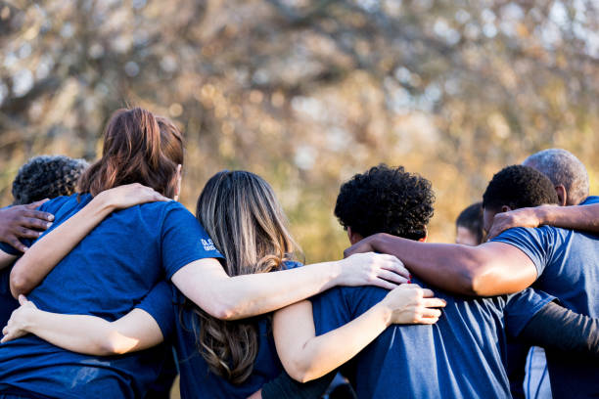
To put you at ease,
People will always need people.
To make life appealing
And give life some meaning,
It’s useful to have other people.
It you need a change
To whom will you turn.
If you need a lesson
From whom will you learn.
If you need to play
You’ll know why I say
People will always need people.
As girlfriends
As boyfriends
From Bombay
To Ostend,
People will always need people
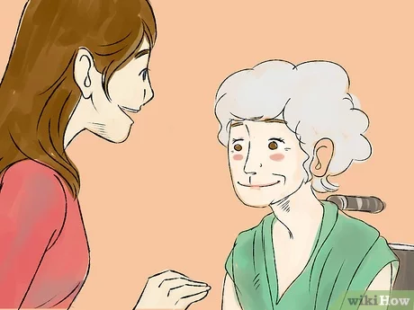
To have friendly fights with
And share tasty bites with,
It’s useful to have other people.
People live in families
Gangs, posses and packs,
It seems we need company
Before we relax,
So stop making enemies
And let’s face the facts,
People will always need people,
Yes
People will always need people.

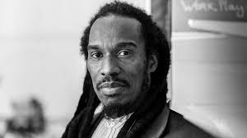

In Flanders’ Fields – John McCrae
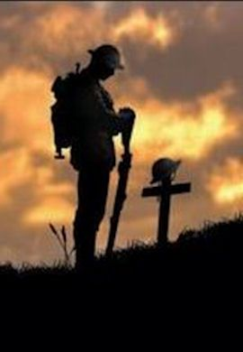
In Flanders' fields the poppies blow
Between the crosses, row on row,
That mark our place: and in the sky
The larks, still bravely singing, fly
Scarce heard amid the guns below.

We are the dead. Short days ago
We lived, felt dawn, saw sunset glow,
Loved and were loved, and now we lie
In Flanders' fields.

Take up our quarrel with the foe;
To you from failing hands we throw
The torch; be yours to hold it high,
If ye break faith with us who die
We shall not sleep, though poppies grow
In Flanders' Fields.

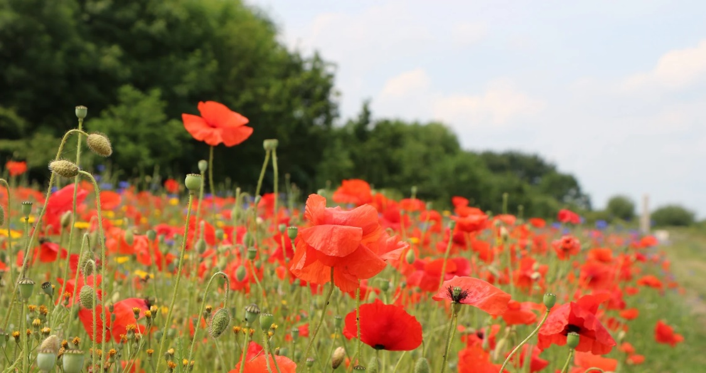

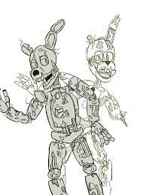
WipWapWop – Jennifer Watson
My Wipwapwop, it cost a lot
I keep it up my sleeve
it's great for surfing on the spot
and playing make believe.
It's sleek and snug and mine to hug
to fuggle and to frowse,
I give it sweets, fresh bugs to tweet
and smarticles to browse.
Its fur's all soft and snootable
its workings quite inscrutable
but fundrous to behold,
its buttons bling, its nodals sing
invincible and bold.
I love its pod, its nanonoo
I crave its little frunes
but more than anything I love
its mazy little tunes.
It cost a lot, my Wipwapwop
but I'm totally conversion
until the day, that grabcious day
they bring out a newer version.

The Tyger – William Blake
Tyger Tyger, burning bright,
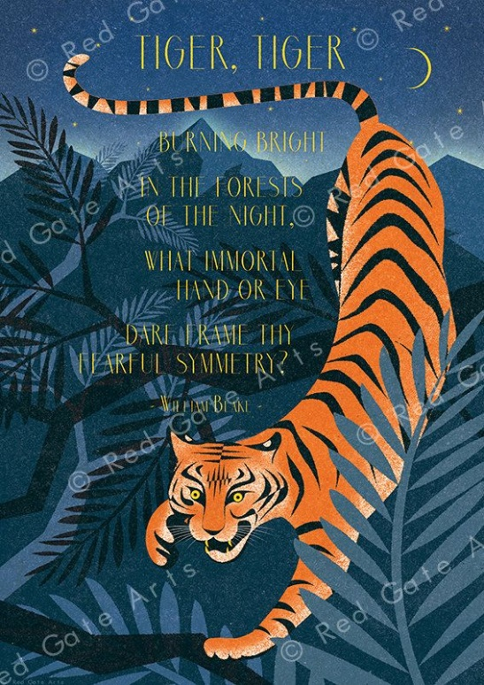
In the forests of the night;
What immortal hand or eye,
Could frame thy fearful symmetry?
In what distant deeps or skies.
Burnt the fire of thine eyes?
On what wings dare he aspire?
What the hand, dare seize the fire?
And what shoulder, & what art,
Could twist the sinews of thy heart?
And when thy heart began to beat,
What dread hand? & what dread feet?
What the hammer? what the chain,
In what furnace was thy brain?
What the anvil? what dread grasp,
Dare its deadly terrors clasp!
When the stars threw down their spears
And water’d heaven with their tears:
Did he smile his work to see?
Did he who made the Lamb make thee?
Tyger Tyger burning bright,
In the forests of the night:
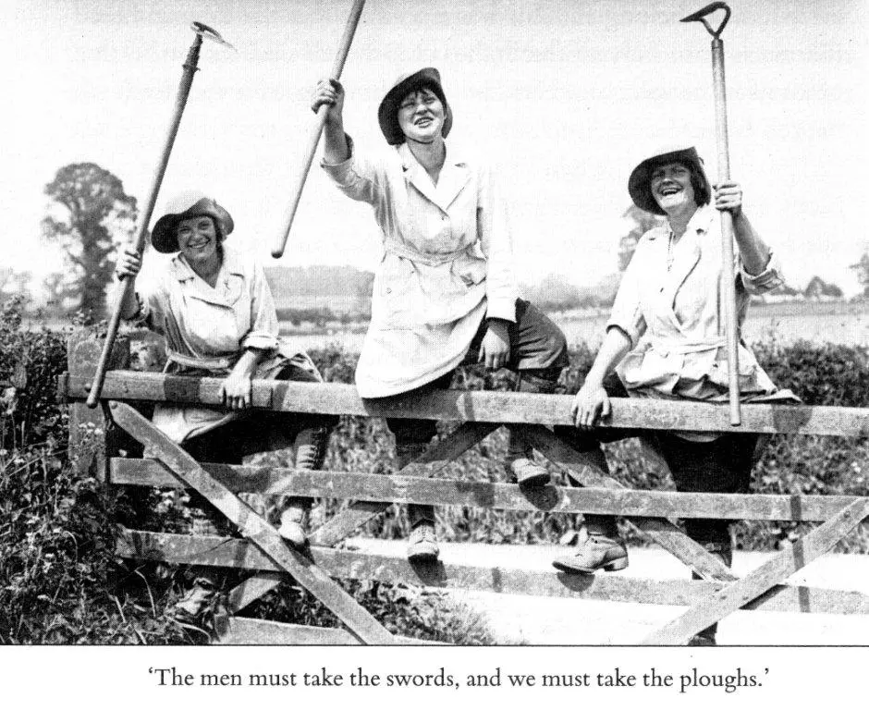
What immortal hand or eye,
Dare frame thy fearful symmetry?

The Women’s Land Army – Rose Perritt
A world of chaos, a world at war,
Destruction as never seen before,
A world of heartbreak, world of fear,
And misery so hard to bear.
Armies wrong, and Armies right,
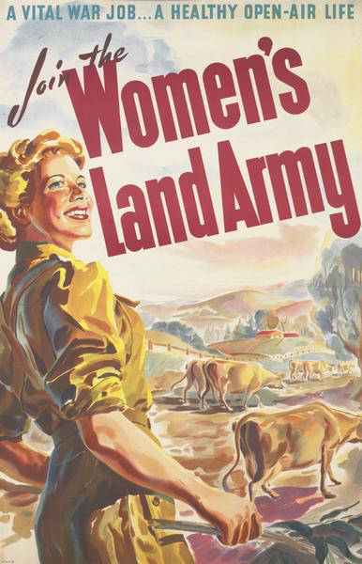
Marching forth to kill and fight,
And lo, the toll of death was high.

An Army came, but not to kill,
Only hungry mouths to fill,
An Army clad in brown and green,
About the countryside was seen,
Around the farmyards, on the roads,
With horses, carrying heavy loads,
A women’s army, firm of hand,
Had come to conquer on the Land.

In lonely ones, or gangs together,
In strange fantastic English weather,
That never a moment may be lost,
In tearing winds and biting frost,
They tended livestock, planted seed,
Tilled, manured, conquered weed,
Picked potatoes, cabbage, beet,
So that England still could eat.

Now a world at peace, a world still mad,
A world all blasted, weary, sad,
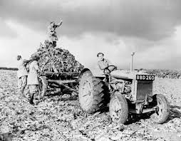
A lot more hungry mouths to fill,
The green Army is needed still,
Little reward will come their way,
But beauty in their hearts will stay,
That comes to those that understand,
Love of a horse, the love of the land.

