Incy Wincy Spider

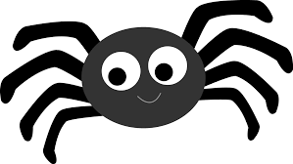
Incy Wincy spider climbing up the spout
Down came the rain and washed the spider out
Out came the sunshine and dried up all the rain
And Incy Wincy spider climbed up the spout again

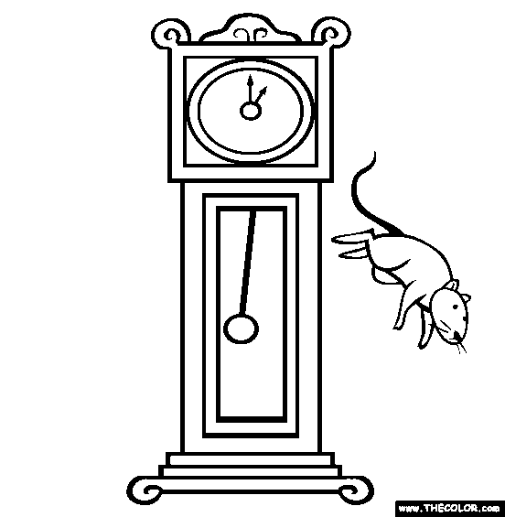
Hickory Dickory Dock
Hickory dickory dock. The mouse went up the clock
The clock struck one. The mouse went down
Hickory dickory dock
Tick tock, tick tock, tick tock, tick tock

Sing a Song of Sixpence
Sing a song of sixpence a pocket full of rye,
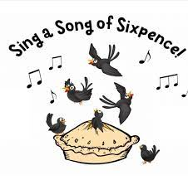
Four and twenty blackbirds baked in a pie.
When the pie was opened the birds began to sing,
Oh wasn't that a dainty dish to set before the king?
The king was in his counting house counting out his money,
The queen was in the parlour eating bread and honey
The maid was in the garden hanging out the clothes,
When down came a blackbird and pecked off her nose!

Alligator – Grace Nichols
If you want to see an alligator
you must go down the muddy slushy end
of the old Caroony River.
I know an alligator who’s living down there.
She’s a-big. She’s a-mean. She’s a-wild.
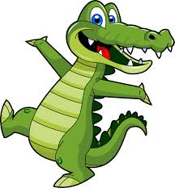
She’s a-fierce.
But if you really want to see an alligator
you must go down to the muddy slushy end
of the old Caroony River.
Go down gently to that river and say
‘Alligator Mama
Alligator Mama
Alligator Mamaaaaaaa.’
And up she’ll rise
but don’t stick around
RUN FOR YOUR LIFE.

Eletelephony - Laura Elizabeth Richards
Once there was an elephant,
Who tried to use the telephant—
No! No! I mean an elephone
Who tried to use the telephone—
(Dear me! I am not certain quite
That even now I've got it right.)
Howe'er it was, he got his trunk
Entangled in the telephunk;
The more he tried to get it free,
The louder buzzed the telephee—
(I fear I'd better drop the song
Of elephop and telephong!)

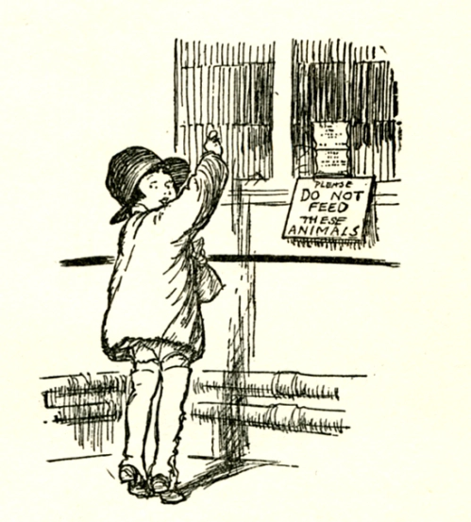
Now We Are Six – A.A. Milne
When I was one,
I had just begun.
When I was two,
I was nearly new.
When I was three,
I was hardly me.
When I was four,
I was not much more.
When I was five,
I was just alive.
But now I am six,
I'm as clever as clever.
So I think I'll be six now
for ever and ever.
Saw My Teacher On A Saturday – Dave Crawley
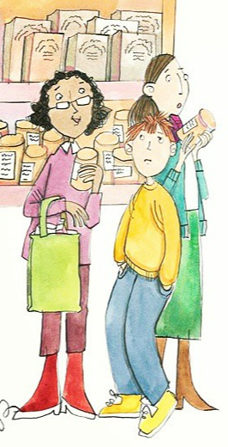
Saw my teacher on a Saturday
I can’t believe it’s true!
I saw her buying groceries,
like normal people do!

She reached for bread and turned around,
and then she caught my eye.
She gave a smile and said, “Hello.”
I thought that I would die!

“Oh, hi…hello, Miss Appleton,”
I mumbled like a fool.
I guess I thought that teacher types
spend all their time at school.

To make the situation worse,
my mom was at my side.
So many rows of jars and cans.
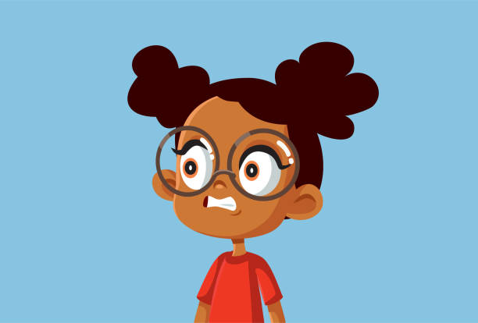
So little room to hide.

Oh please, I thought, don’t tell my mom
what I did yesterday!
I closed my eyes and held my breath
and hoped she’d go away.

Some people think it’s fine to let
our teachers walk about.
But when it comes to Saturdays,
they shouldn’t let them out!

Granny is – Valerie Bloom
Granny is
fried dumplin’ an’ run-dung,
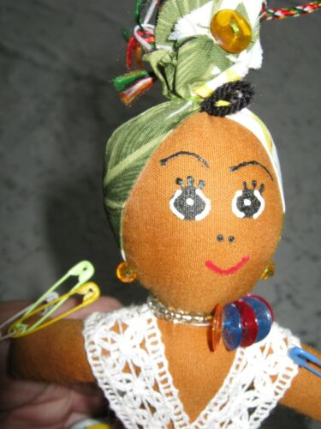
coconut drops an’ grater cake,
fresh ground coffee smell in the mornin’
when we wake.

Granny is
loadin’ up the donkey,
basket full on market day
with fresh snapper the fisherman bring back
from the bay.

Granny is
clothes washin’ in the river
scrubbin’ dirt out on the stone
haulin’ crayfish an’ eel from the water
on her own.

Granny is continued….
Granny is
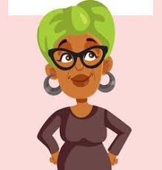
stories in the moonlight
underneath the guangu tree
and a spider web of magic
all round we.

Granny say,
‘Only de best fe de gran’children,
it don’ matter what de price,
don’t want no one pointin’ finger.’

Granny nice.

On the Ning Nang Nong – Spike Milligan
On the Ning Nang Nong
Where the Cows go Bong!
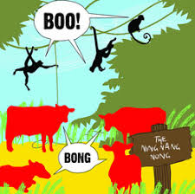
and the monkeys all say BOO!
There's a Nong Nang Ning
Where the trees go Ping!
And the tea pots jibber jabber joo.
On the Nong Ning Nang
All the mice go Clang
And you just can't catch 'em when they do!
So its Ning Nang Nong
Cows go Bong!
Nong Nang Ning
Trees go ping
Nong Ning Nang
The mice go Clang
What a noisy place to belong
is the Ning Nang Ning Nang Nong!!

Stars – Gareth Lancaster
Look at the stars,
Way up there,
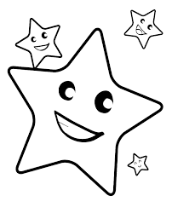
So very far away.
High in the sky,
They shine so white,
And never seem to stray.

Like little dots,
Or specks of paint,
Just floating up above.
I wonder,
What they do up there,
And what they are made of.

Are they just holes,
Poked out the sky,
By giants long ago?
Or maybe they're,
Electric lights,
Strung up to make a show!

So far up there,
I'd like to be,
To take a look first hand.
To just get close,
And have a peek,
That really would be grand!

