Ye Spotted Snakes – William Shakespeare
Ye spotted snakes with double tongue,
Thorny hedgehogs, be not seen;
Newts and blindworms, do no wrong,
Come not near our fairy Queen.

Philomele, with melody
Sing in our sweet lullaby;
Lulla, lulla, lullaby, lulla, lulla, lullaby:
Never harm
Nor spell nor charm,
Come our lovely lady nigh;
So, good night, with lullaby.

Weaving spiders, come not here;
Hence, you long-legged spinners, hence!
Beetles black, approach not near;
Worm nor snail, do no offence.

Philomele, with melody
Sing in our sweet lullaby;
Lulla, lulla, lullaby, lulla, lulla, lullaby:
Never harm
Nor spell nor charm,
Come our lovely lady nigh;
So, good night, with lullaby.

Life Doesn’t Frighten Me At All – Maya Angelou
Shadows on the wall
Noises down the hall
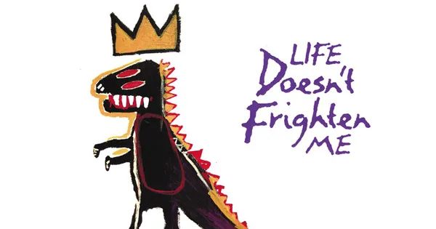
Life doesn't frighten me at all

Bad dogs barking loud
Big ghosts in a cloud
Life doesn't frighten me at all

Mean old Mother Goose
Lions on the loose
They don't frighten me at all

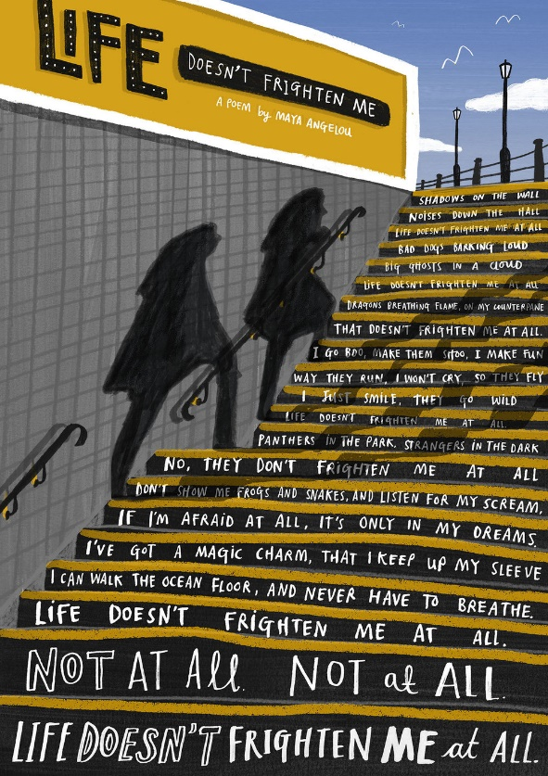
Dragons breathing flame
On my counterpane
That doesn't frighten me at all.

I go boo
Make them shoo
I make fun
Way they run
I won't cry
So they fly
I just smile
They go wild

Life doesn't frighten me at all.

Tough guys fight
All alone at night
Life doesn't frighten me at all.

Panthers in the park
Strangers in the dark
No, they don't frighten me at all.
That new classroom where
Boys all pull my hair
(Kissy little girls
With their hair in curls)
They don't frighten me at all.

Don't show me frogs and snakes
And listen for my scream,
If I'm afraid at all
It's only in my dreams.

I've got a magic charm
That I keep up my sleeve
I can walk the ocean floor
And never have to breathe.

Life doesn't frighten me at all
Not at all
Not at all.

Life doesn't frighten me at all.

Walking With My Iguana – Brian Moses
I’m walking
with my iguana.
I’m walking
with my iguana.
When the temperature rises
to above eighty-five,
my iguana is looking
like he’s coming alive.
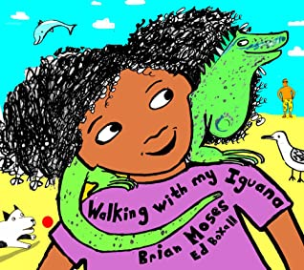
So we make it to the beach,
my iguana and me,
then he sits on my shoulder
as we stroll by the sea . . .
and I’m walking
with my iguana.
I’m walking
with my iguana.
Well if anyone sees us
we’re a big surprise,
my iguana and me
on our daily exercise,
till somebody phones
the local police
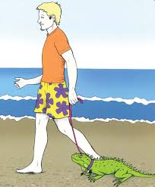
and says I have an alligator
tied to a leash.
My Iguanaby Brian Moses
Walking With
When I’m walking
with my iguana.
I’m walking
with my iguana.
It’s the spines on his back
that make him look grim,
but he just loves to be tickled
under his chin.
And I know that my iguana
is ready for bed
when he puts on his pyjamas
and lays down his sleepy head.
And I’m walking
with my iguana.
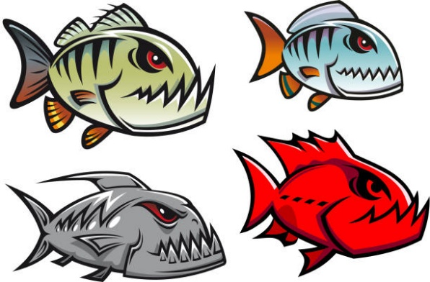
Still walking
with my iguana.
With my iguana . . . . . . . . . . . . . .
with my iguana . . . . . .
and my piranha,
and my chihuahua,
and my chinchilla,
and my gorilla,
my caterpillar . . . . .
and I’m walking . . .
with my iguana . . .
with my iguana . . .
with my iguana . . .

Flame by Rachel Rooney
Fire under footfall.
Fire over skies.
Fire on a matchstick.
Fire in my eyes.
Fire holding hunger.
Fire seeking wood.
Fire hiding danger.
Fire feeling good.
Fire as the enemy.
Fire acting friend.
Fire I must stamp on.
Fire I must tend.
Fire in the embers.
Fire at the heart.
Fires to remember.
Fires yet to start.

Rain Dance – Hilda Offen

The seagulls are doing their dance again – Wings clasped to their sides, they stare up the street.
Up and down, up and down, go their knobbly pink knees;
And boom-diddy-boom! drum their heavy webbed feet.

“Hey!” whisper the worms in the dry, blackened earth.

“Can you hear the rain fall – pitter-pat! Pitter-pat?
Let's get some of that – let's hurry! Let's go!”
And they wriggle on up to the rat-a-tat-tat!

While over their heads, the dancers pound on;
Their golden beaks shine in the midsummer heat – Intent on their dance, in a world of their own;
And boom-diddy-boom! go their heavy flat feet.

“Come on!”“ call the worms. “It's raining up there!
There'll be rich, fruity earth – we'll have it for tea.”
Out pop their heads in the shimmering air.
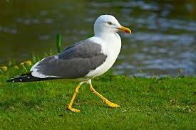
Dart! Snap! and swallow! How wrong can you be?

